Examine

<https://pactflow.io/>

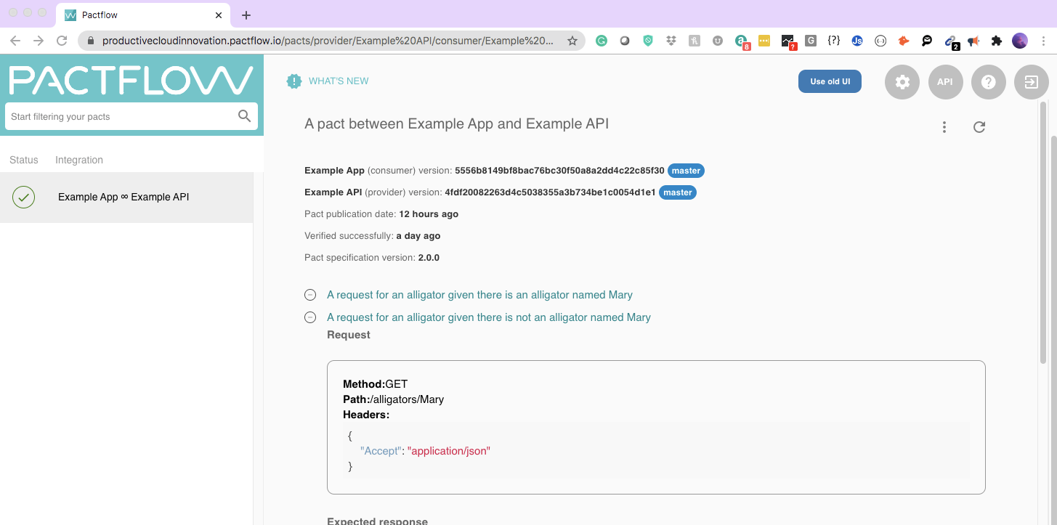

https://github.com/anha1/microservices-pact-maven

STS

FROM: /Users/rbhardwaj/Documents/00Technology/Spring/microservices-pact-maven

java -jar microservices-pact-provider/target/fat-microservices-pact-provider-1.0.0-SNAPSHOT.jar

UI:

mvn au.com.dius:pact-jvm-provider-maven_2.11:verify

localhost:8080/foos